**Chemical Industry Growth**

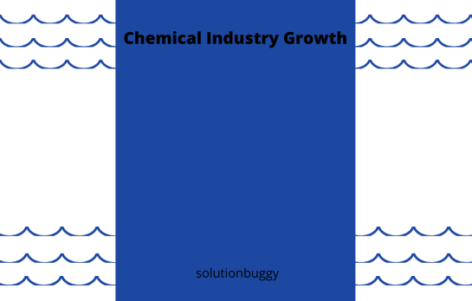

Chemical sector has been the 3rd largest contributor to GDP amongst manufacturing industries for year 2017 in India.

200% weighted average reduction of tax from the Income tax department for both capital and revenue expenditure incurred on scientific R&D

Currently industry is employing more than 2mn people

There is a high demand for producing specialty chemicals, agro chemicals, petrochemicals, dye intermediaries and dyestuff and existing plants are operating at maximum capacity

100% FDI is allowed under automatic route in chemicals sector and upcoming Chemicals and Petrochemicals Investment Regions (PCPIRs) and Plastic parks will give boost to new entrepreneurs in [chemical industry](http://bit.ly/3181nBK)

Heavy compliance requirement from government regarding environment policy means high reliance on consultants

Get expert advice from highly qualified [chemical consultants](http://bit.ly/3181nBK) with average experience of 16 years in the domain

India is backed by the strongest growth rate in the GDP by the Chemical industry, hence the future looks bright as well. The [Chemical Industry](http://bit.ly/3181nBK) of India ranks 6th in world and 3rd in Asia after Japan and China. In terms of global shipments of chemicals, India ranks 10th in the world. It not only contributes to the GDP but is also like a cornerstone for many of the manufacturing industries in the country and in the world. Likewise is the pharmaceutical industry of India, which is now known to be the third largest market in terms of the volume. Pharmaceuticals has shown a consistent growth in fact, Indian vaccines and generic drugs have found its market in about 150 countries.

Pharmaceutical industry falls under the sector where the standard and the quality become much more valuable and important compared to other industries.Just with a business plan, and investors a chemical or pharmaceutical industry cannot be started. The rules of the chemical or specifically pharmaceuticals lay that one of the partners must be a registered pharmacist, failing which the company must hire a pharmacist on its behalf with an authority to make changes. The drug license must be obtained by filing in various forms that would seek government approval of manufacture and sale of SCHEDULE C (BIOLOGICAL AND SPECIAL PRODUCTS), SCHEDULE C (1) drugs and approvals from the local Drug inspector.

#### With Make in India in place, the investment in the manufacturing sector has been made more attractive, the chemical/pharmaceutical industry is getting a global exposure, to expand and enhance which would lead to the generation of employment and also gains a competitive authority. In terms of research and development, the government Weighted tax deduction of 200% under section 35 (2AB) of the Income Tax Act for both capital and revenue expenditure incurred on scientific research and development. With newest of schemes like 59 minutes loan for MSMEs, the manufacturing industries can get up to 1 crore loan which would help the industries expand, and enhance the potential. India has an upper hand as the cost of production of the pharmaceutical drugs are relatively lower than US and much lower than UK.

#### Even with the amplified growth rate and government incentives, the industry does not escape itself from challenges. Like the ancient strategy models, the pharmaceuticals still tend to follow old strategies and modelswith outdated methods.There is still lack of knowledge on how to structure their innovation, marketing and sales, manufacturing, and portfolios accordingly. This is where the well experiencedpharma consultants come in and study the company and its place in the market and help them take the road to progress.

Compliance; another major challenge a chemical or pharma industry faces is the government policies and to be compliant with the policies. The companies also tend to face a low margin of profits due to the government pricing policies. Pharma and chemical consultants here can ease the burden of a proprietor by helping them to stay compliant to the government regulations, any updation in the new policy and benefitting from policies.

The act of transformation is unhurried. The technology, automation, innovation is not the strength of the Indian chemical or pharmaceutical industry but is rather seen as a weakness. A company to overcome this challenge must put in a lot of effort in Research and development and consultants are known to be the aide to the challenge. By judging the company, a consultant might be able to assist the company in amplifying the technological knowledge and adaption.

SolutionBuggy which is the fastest growing platform to connect manufacturing industries with consultants has helped many new entrepreneurs looking to setup chemical/pharma related units by giving them the best in class chemical consultants & pharma consultants who have eased the efforts required to setup the units, manage all the compliance issues, train the employees, help them in the sales and distribution, get contract manufacturing orders, help them with GMP and EU-GMP approvals etc. We have also worked on projects for existing industries who wanted to add a new product line, increase efficiency, implement lean manufacturing process or improve employee output through training.

Company phone no: 080-42171111

Website: www.solutionbuggy.com

Email: sales@solutionbuggy.com